Capstone Project

**Course code:** CSA4385

**Course:** Internet Programming for Green App

**Team:** 02

**Name:**

1. B. Rushitha
2. P.Yaswitha

**Registration no:**

192211332

192210013

**Slot:** B

**Title:** FITPRO INC-HEALTH AND WELLNESS APPLICATION

**Guided by:** Venkatesan sir

**Department:** CSE

**College:** Saveetha School of Engineering



**FITPRO INC-HEALTH AND WELLNESS APPLICATION**

OBJECTIVE:

To improve a healthy diet and wellness for people to increase awareness of nutrition information and manage a perfect diet for Breakfast, Lunch and Dinner, thereby, it helps in enhancing good diet plan and awareness while reducing improper diet planning.

Modules:

1.Login Page

2.Product Page

3.Product Info

4.Diet box

5.Diet Plans

6.Suggestions

7. Create diet list.

8. User Questions Page

9.Admin Page

          10. Add Product

GANTT CHART:

|  |  |  |  |  |  |  |  |  |  |
| --- | --- | --- | --- | --- | --- | --- | --- | --- | --- |
| DURATION / TASK | 06.02.2024-07.02.2024 | 08.02.2024-09.02.2024 | 10.02.2024-12.02.2024 | 12.02.2024-14.02.2024 | 15.02.2024-20.02.2024 | 23.03.2024-25.03.2024 | 26.03.2024-27.03.2024 | 28.03.2024 | 29.03.2024 |
| Project Title Selection |  |  |  |  |  |  |  |  |  |
| MODULE 1 |  |  |  |  |  |  |  |  |  |
| MODULE 2 |  |  |  |  |  |  |  |  |  |
| MODULE 3 |  |  |  |  |  |  |  |  |  |
| MODULE 4 |  |  |  |  |  |  |  |  |  |
| MODULE 5 |  |  |  |  |  |  |  |  |  |
| DEMO |  |  |  |  |  |  |  |  |  |
| PRESENTATION |  |  |  |  |  |  |  |  |  |

INTRODUCTION:

FITPRO INC is a leading innovator in the realm of health and wellness applications, dedicated to revolutionizing the way individuals engage with their fitness goals and overall well-being. With a profound understanding of the contemporary lifestyle demands and the importance of holistic health, FITPRO INC has crafted a comprehensive platform designed to empower users in their journey towards optimal wellness.

At the core of FITPRO INC's ethos is the belief that technology can serve as a catalyst for positive lifestyle changes. By seamlessly integrating cutting-edge technology with evidence-based health principles, FITPRO INC offers users an intuitive and personalized experience that transcends traditional fitness applications.

The FITPRO INC Health and Wellness Application is meticulously crafted to cater to the diverse needs of users, whether they are seasoned athletes, fitness enthusiasts, or individuals embarking on their wellness journey for the first time. Through a combination of innovative features, including personalized workout plans, nutritional guidance, progress tracking tools, and motivational support, the application empowers users to take control of their health in a sustainable and enjoyable manner.

Furthermore, FITPRO INC understands the importance of community and support in achieving long-term health goals. Therefore, the application fosters a vibrant community where users can connect, share experiences, and motivate each other towards success. Whether through virtual challenges, group workouts, or expert-led discussions, FITPRO INC cultivates an environment where users feel supported and inspired to strive for their best selves.

In essence, the FITPRO INC Health and Wellness Application represents a paradigm shift in how individuals approach their health and fitness journey. By harnessing the power of technology, personalized guidance, and community support, FITPRO INC empowers users to unlock their full potential and live life to the fullest.

**LOGIN PAGE**

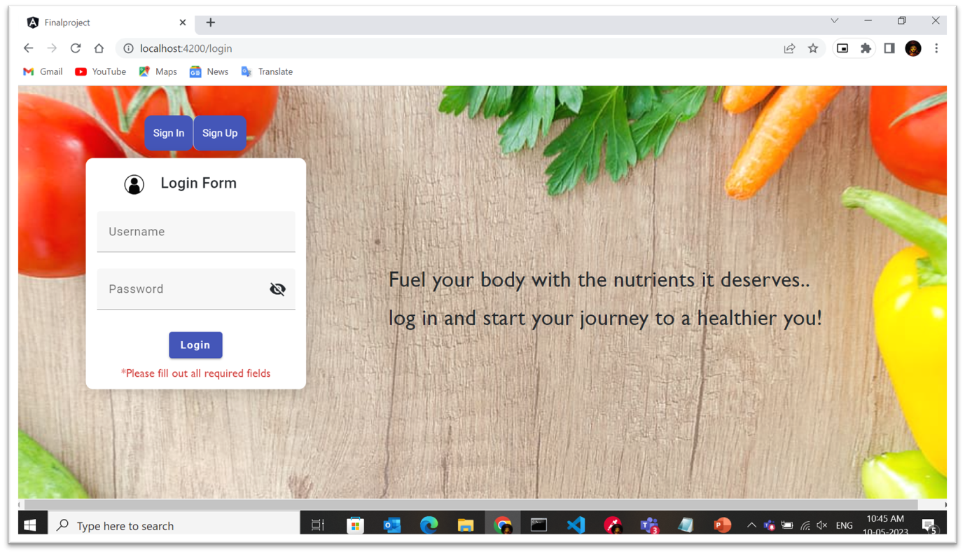

**PRODUCT PAGE**

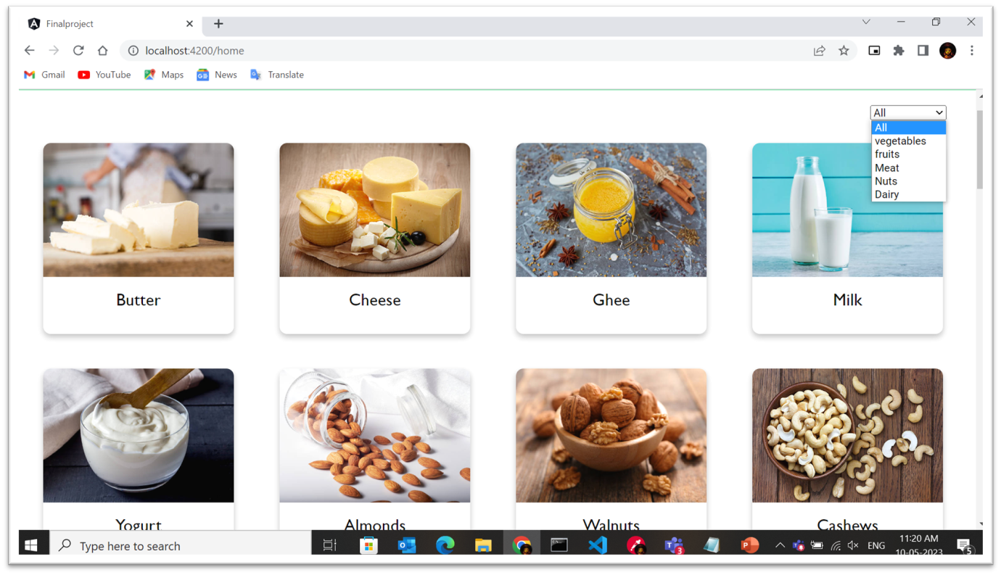

**PRODUCT INFO**

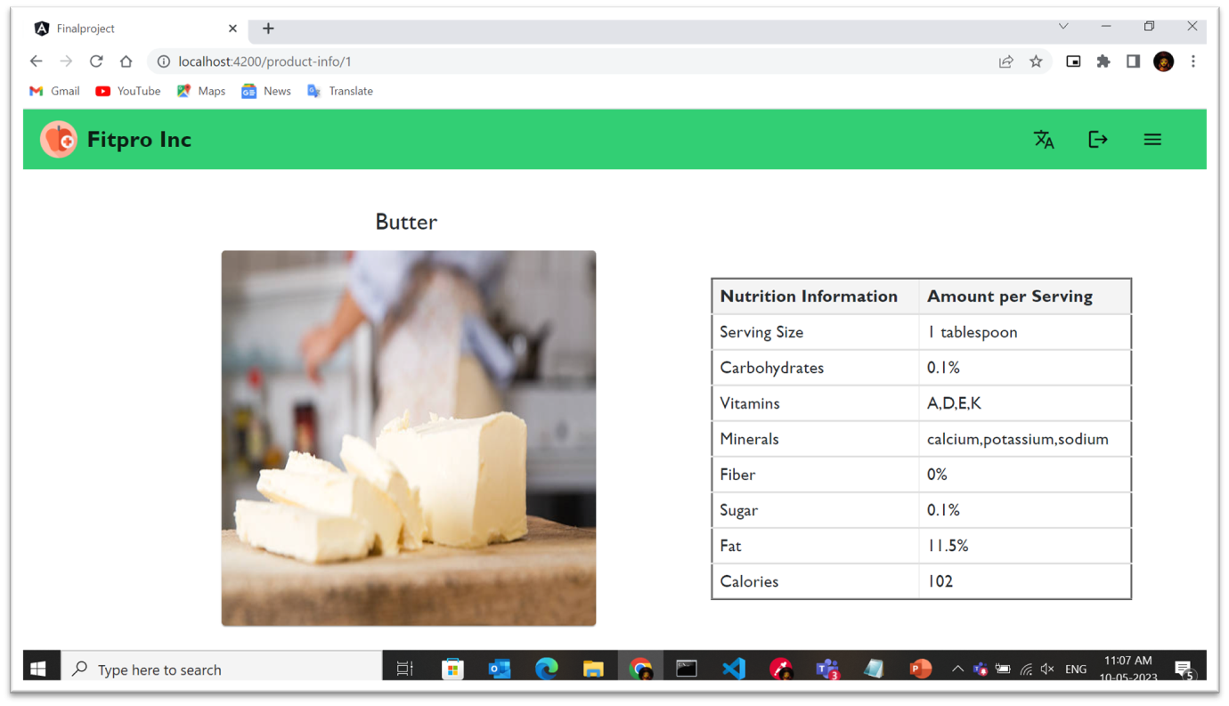

**DIET BOX**

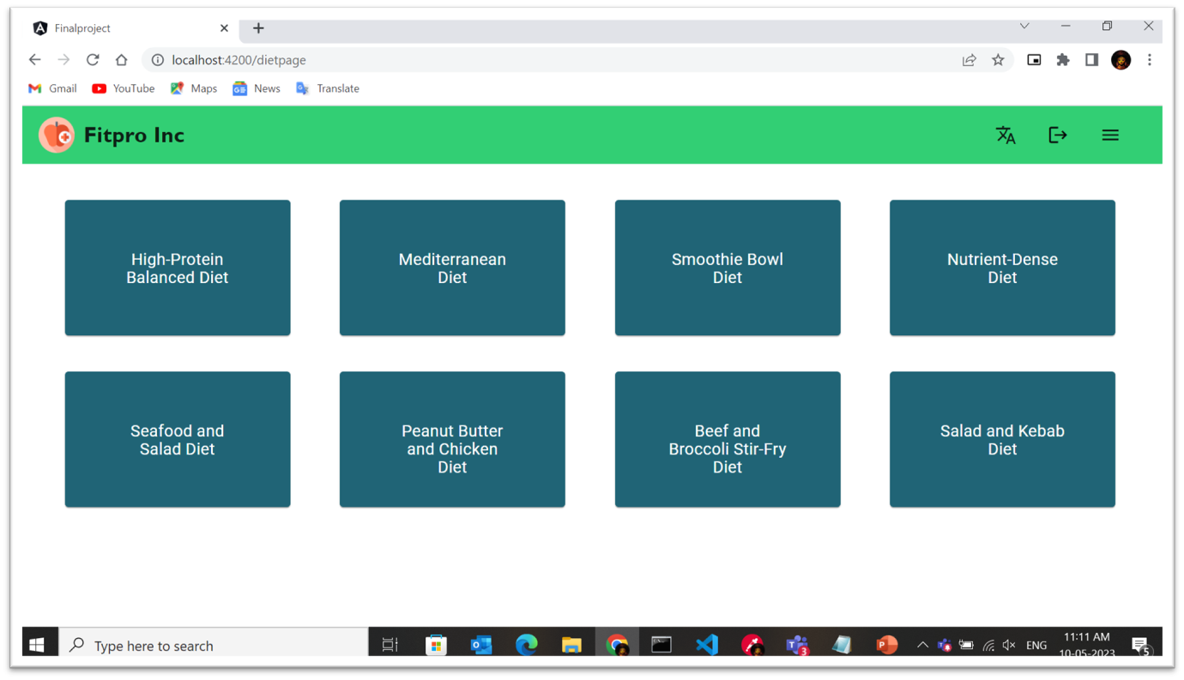

**DIET PLAN**

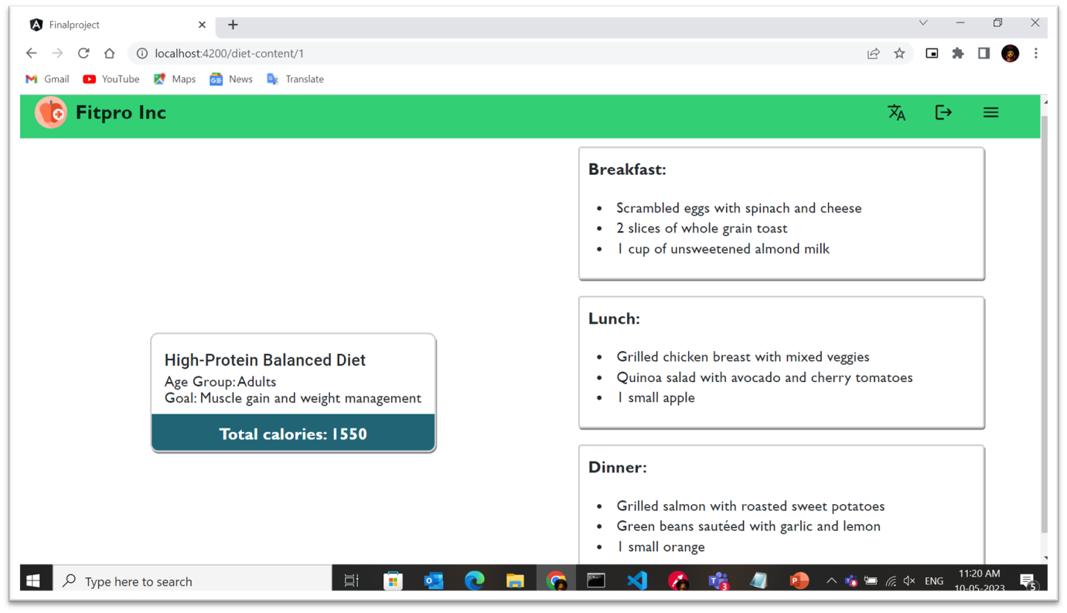

**SUGGESTIONS**

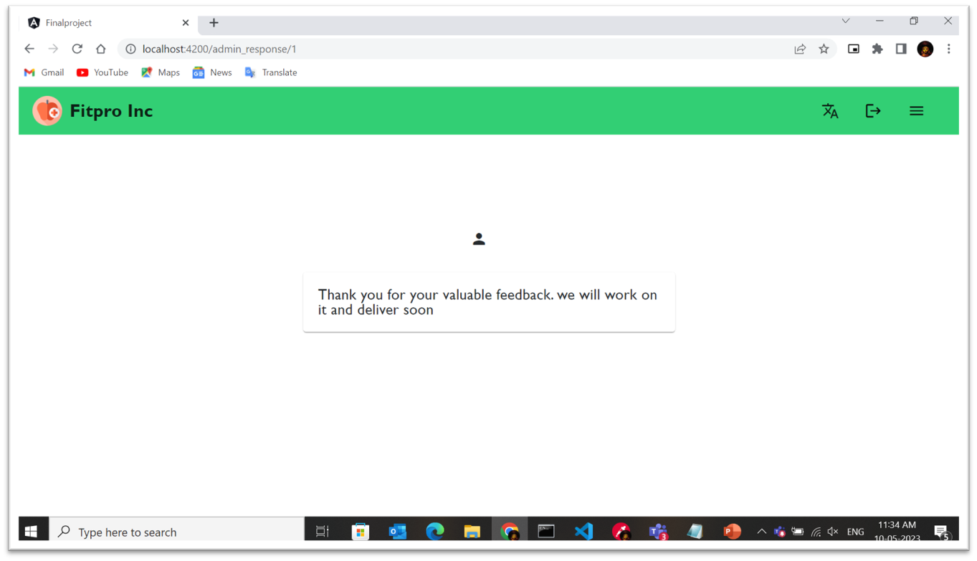

**CREATE DIET LIST**

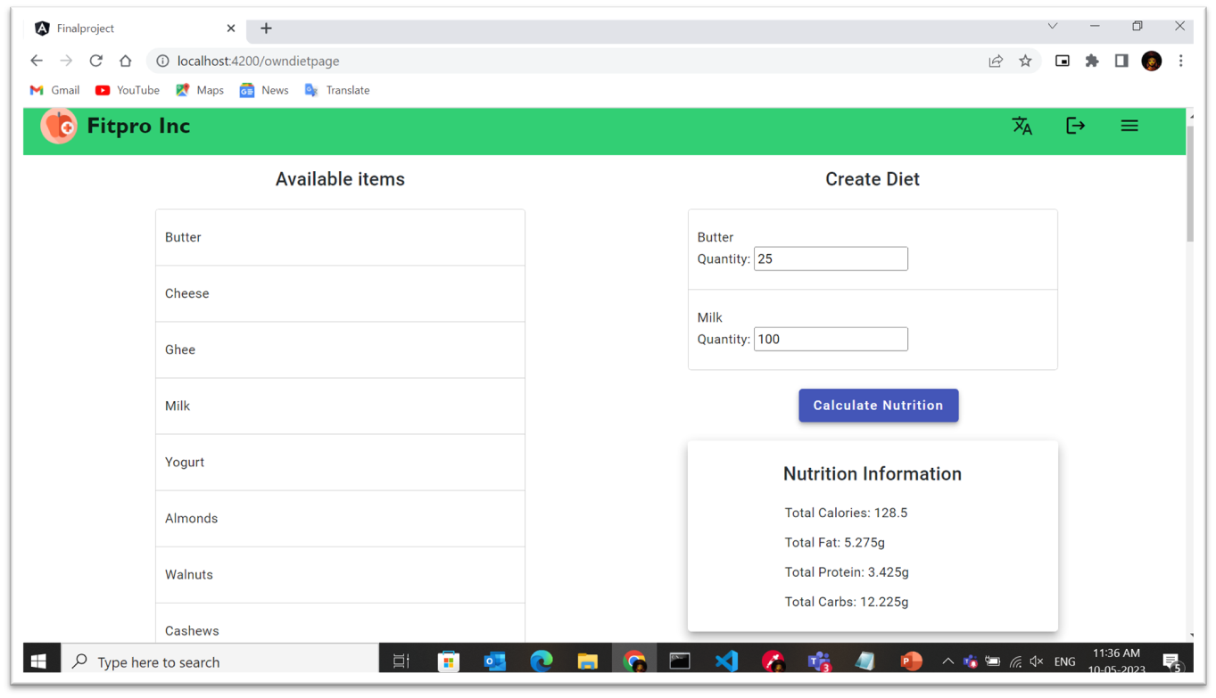

**USER QUESTIONS PAGE**

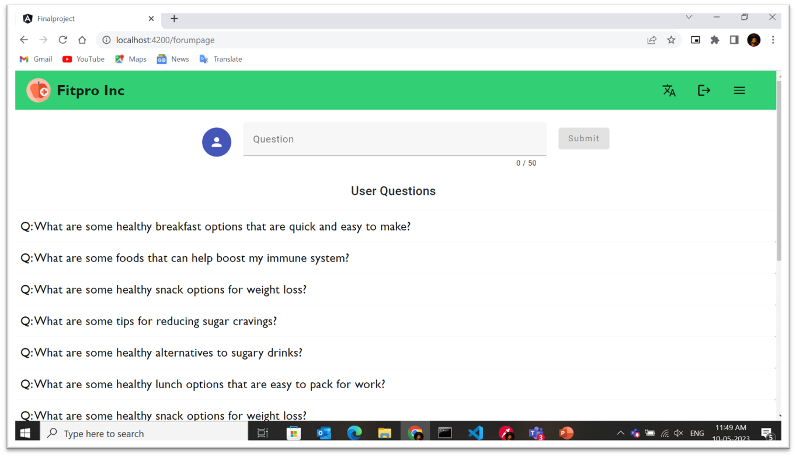

ADMIN PAGE

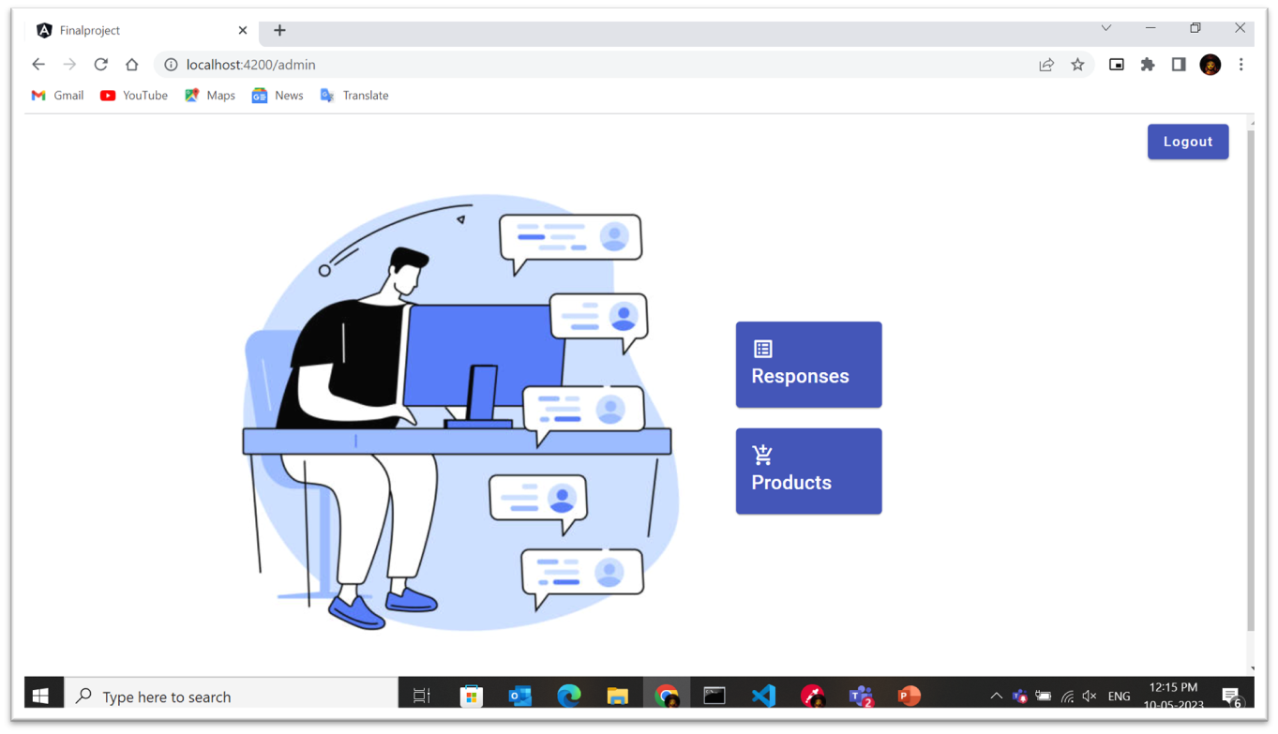

**ADD PRODUCT**

